Clothes Make the Man
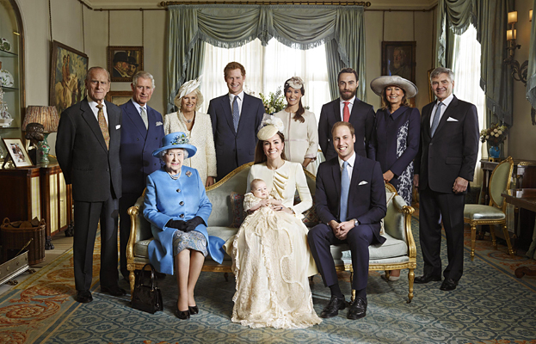
#1
You go on a vacation to an isolated island; no one is around for the next week.
You have a lot of delicious food, your air-conditioned hut is right by the best beach in the world, the weather is perfect, and you don’t really need any clothing.

Question: For the next seven days, would you -
(a) not put any clothing on?
(b) put on only the bare minimum?
(c) dress as usual, just as you do when you are around other people?
Explain why!

#2
Minor Pesikta, Devarim (Ki Savo) 41a
“And there they became a nation” – this teaches that the Jewish people were distinct there (in Egypt), in that their clothing, food, and language were different from the Egyptians’.

Torah Shemos 28:2
You shall make vestments of sanctity for Aaron your brother (high priest), for honor and beauty.

Shulchan Aruch, Orach Chaim 2:3, Mishnah Berurah
A Jew must always be careful to dress in a dignified manner.

Questions:
(a) What is the purpose of clothes?
(b) There is a trend in recent years to dress as little as possible - why do most people still feel the need to wear at least something?
(c) What is the purpose of a uniform - e.g. school, officials?
(d) Why do people who work in finance wear suits? Would it make any difference in their performance if they wore jeans and polo shirts etc? Or is it just to show their status?
(e) Only people wear clothing - animals, birds etc are fine without them.
What’s the reason for this? Do clothes actually “make the man”? How do clothing distinguish us from the animal world?
(f) Why is clothing one of the attributes that separates one nation from another?
(g) What is unique about Jewish clothing?
(h) Wearing garments is a superficial thing. Why do Jews place such importance in them?

#3
Halichos Bas Yisrael, 4:4
Jewish Law requires that the following parts of a married or unmarried woman’s body be covered in public:
a) The neck (below and including the collarbone)
b) The arms (the upper arms, including the elbow)
c) The legs (the thighs, including the knees)
A woman is required to wear a dress or skirt which is long enough to cover her knees whether she is standing or sitting …

Questions:
(a) What do the laws of dressing modestly accomplish?
(b) Why is Jewish law stricter regarding the clothes of a woman than of a man?

Talmud Shabbos 114a
It is forbidden for a Torah scholar to wear a stained garment.

(c) Why is Jewish law more strict regarding the clothes of a Torah scholar than any other Jew?

#4
Torah Bereshis
2:17
And G-d commanded the man, saying, “of every tree of the garden you may freely eat; but of the Tree of Knowledge of Good and Bad, you must not eat thereof …”
2:25
And they were both naked, the man and his wife, and they were not ashamed.

(After they sinned against G-d and ate from the Tree of Knowledge of Good and Bad:)

3:7-11
And their eyes were opened, and they knew they were naked and they sewed fig leaves...
They heard the sound of G-d manifesting itself in the garden toward evening; and teh man and his wife hid from G-d among the trees of the garden.
G-d called out to the man and said to him, “Where are you?”
He said, “I heard the sound of You in the garden, and I was afraid because I’m naked, so I hid.”
And He said, Who told you that you are naked? Have you eaten of the tree from which I commanded you not to eat?”
3:21
And G-d made for Adam and his wife garments of skin, and He clothed them.

TODAY’S LEARNING MATERIAL

#5
Hebrew for garment is “beged” – it shares the same root with the word “treachery/traitor”.
Question: What could be the connection?
Talmud Shabbos 77
Clothing in Hebrew “Levush”- it is an acronym of “lo vosh” - “not ashamed”, (that is, prevention of shame).

Question: It seems that there is a very deep connection between clothing and shame. How are they connected?

#6

Beneath the Surface: A Deeper Look at Modesty by Dina Coopersmith (www.aish.com)

Maybe you've noticed women on campus or in the workplace covering up more than usual, wearing long skirts for example, or shirts with sleeves that cover the elbows. What is that all about? Is it a fashion statement? A religious thing? Or some post-modern feminist trend?

In every culture, clothes are a basic requirement. Even in the hot jungles of Africa, the inhabitants wear some minimal form of clothing. Nowhere, however, do animals cover up. Why? What is it about human beings and clothing throughout all ages and across all cultures?

The truth is it wasn't always like this. Once upon a time, human beings didn't wear clothing at all. Albeit for a very short time, Adam and Eve, pre-sin, roamed around the Garden of Eden naked:

Torah Bereshis 2:25
And they were both naked, the man and his wife, and they were not ashamed.

After the sin however, a change took place in their feelings about clothing (or about their lack thereof):

Torah Bereshis 3:7
And their eyes were opened, and they knew they were naked and they sewed fig leaves...

What caused the attitude to change from "au naturel"? What caused the need to cover up? The answer is rooted in an understanding of the sin of Adam and Eve.

According to commentators, through the eating of the fruit from the Tree of Knowledge, the tendency to do evil was internalized within the human psyche. Previously, man and woman had an intellectual choice between good and evil, but evil was outside of the body, a philosophical issue, not an inner pull or an emotional desire.

Before the sin, a person's soul expressed itself through its body. Body and soul were in consonance with each other. For example, when the soul wanted to pray to God, the body rose early and prayed. When the soul wanted to study and grow most effectively, the body ate healthy foods and took care of itself to provide the necessary fuel and energy for the demanding task.

Now, post-sin, a dichotomy exists. Almost dualistic. One's soul wants to pray, his body groans, turns over and shuts off the alarm clock. The soul strives to perfect itself, the body wants to eat chocolate cake, watch television and lie on the beach! The body is no longer in the service of the soul, it no longer runs to do its bidding. Not only is the body not a reflection of the soul, but they are now working at cross-purposes.

What does all this have to do with clothing, modesty and covering up?

When Adam and Eve were in the Garden of Eden, their bodies were a mirror of their souls, there was no need to cover up such a pure innocent expression of a person's spirituality, of God's image within a human being. However, once evil was integrated into man, the body came to represent something antithetical to the soul. Looking at the body could now distract the observer from focusing on his or her internal being and instead focus only on the physical, the external and the superficial.

It became necessary to de-emphasize the physical in order to emphasize the spiritual, to cover up the body in order to let the soul shine through.

Question: What are your thoughts about this article?

#7
Mishnah Berurah 75:7
According to the Jewish law, woman is allowed to have her face and hands revealed.

Question: What could be the reason for this “leniency” in the Jewish law?

#8
Question: What’s your takeaway from today’s discussion?

